Interview with Jurema: A real live Station Agent!
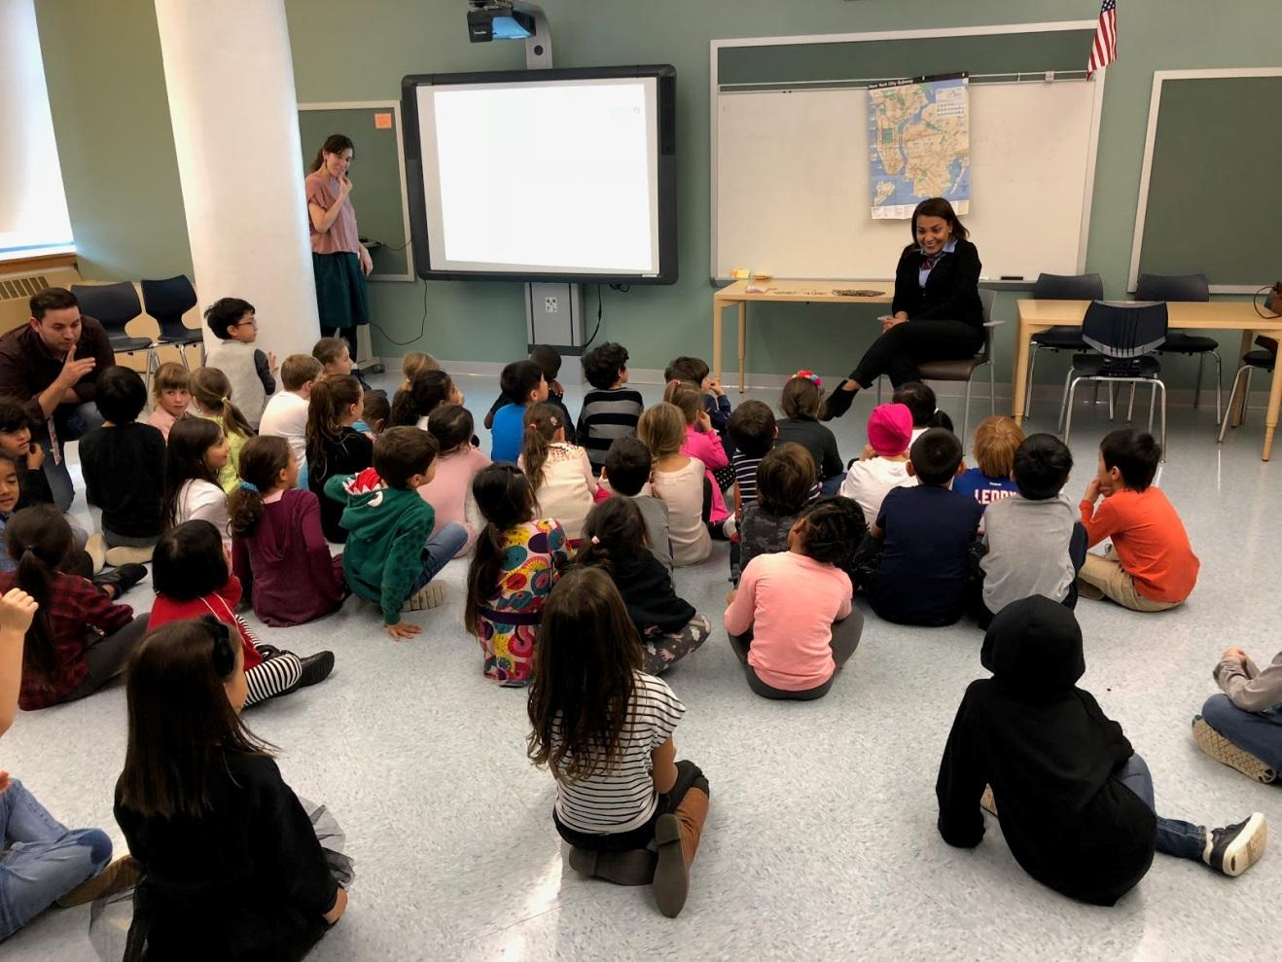
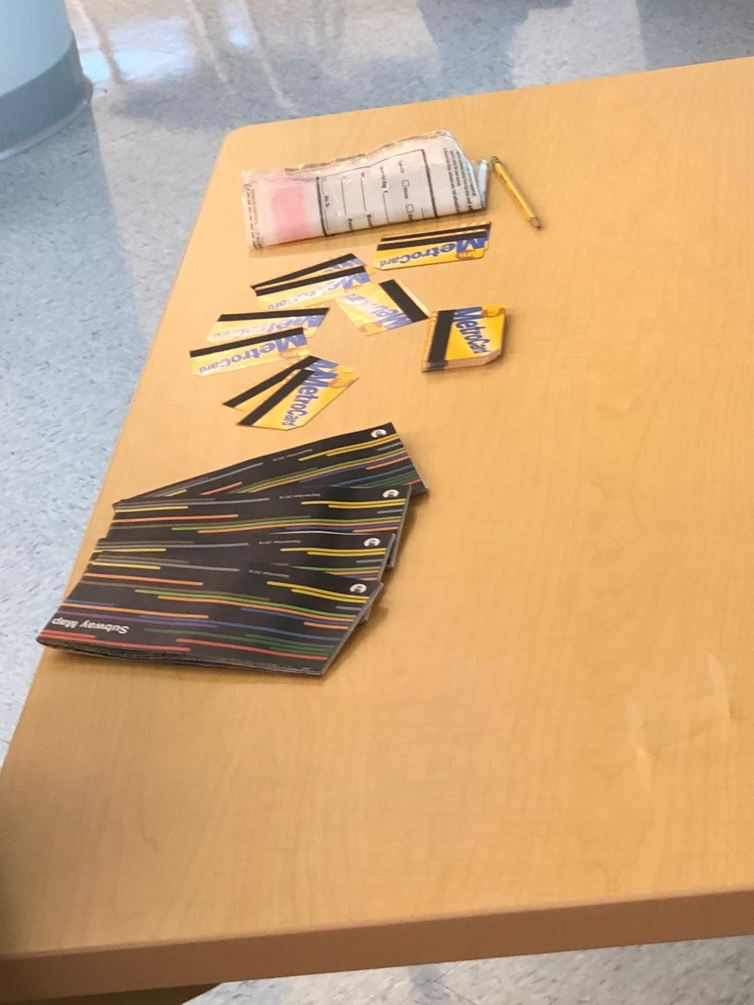
- 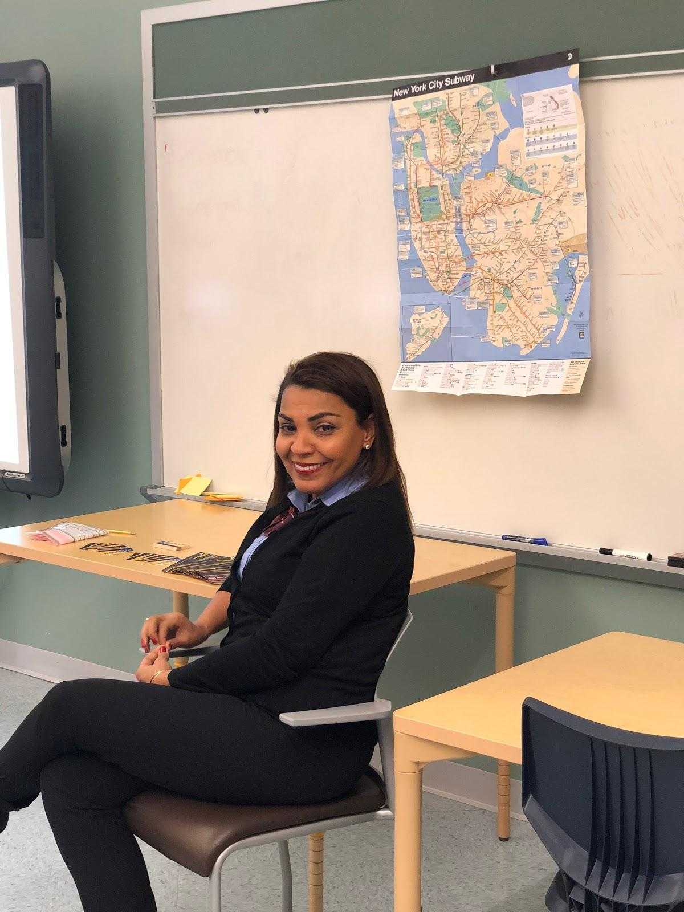She works for the MTA for 22 years.
- “How do you put money on a metrocard?” Inside the booth there’s a computer. We hold the metrocard. The computer has numbers and we enter 5$ or 10$ or 30 days. Then I dip the card and it puts the 10$ on.
- “How do you know all the stuff?” I have been working for so long, and I use maps. Every day I learn a little bit.
- “What days do you work on?” I work 5 days a week and then I’m off on Mondays and Tuesdays.
- “Do you have a uniform?” I wear my MTA shirt, black pants, and MTA scarf.
- “When do you get breaks?” We only take a 30 minute break. Someone else comes to relieve us so we can have coffee or go to the bathroom. But only 30 minutes.
- “What happens if you are sick?” We have to call in 1 hour before your job.
- “What do people usually ask you?” If you ever lose anything inside the train, or station, or on the track, you would come to me and I have a way to get the item back. Go to my booth and I will call someone to help find your item.
- “What is your favorite part of your job?” The people. I get to tell the tourists about the city, or kids about the city. Every day is different.
- “Does anyone ever ask you about weird stops?” Sometimes they don’t listen to the announcement or look at the posters so I have to tell them what trains are not going.
- “Do you have any cameras in the station?” We don’t have cameras but there are cameras inside the station.
- “What time do you wake up?” At 3 o’clock in the morning because I work 5am-1pm.
- “Does anyone ask you about being in trouble?” We have to be the eye and know everything that is going on. We are the ones who can stop the trains, call the ambulance...so we have to know what is going on.
- “What if someone gets sick at the station?” Customers tell us and then we call the police and EMS to send an ambulance.
- “Where is your booth and what does it look like?” I work on 59th street and Columbus Circle.
- “What do you do if no one is there?” I stay there and wait.
- “What are your responsibilities?” I come in, I check the money and count it, I have a lot of keys to check, then I make metrocards, write in books about what is going on in the station...a lot of things in the 8 hours.
- “What time do you get home from your job?” 1pm
- “What do they find in the tracks?” I don’t go there, but they find a lot of stuff there.
- “What restaurant do you mostly go to on your break?” Usually whole foods. 30 minutes goes really fast.
- “What is inside the booth?” 3 telephones: 1 for emergencies. 2 red buttons to press in an emergency. If I press them, they can hear anything going on inside. A computer, printer, money, metrocards, maps, and ourselves. I have 3 fire extinguishers. A small one, a medium one and a big one.
- “Do you give out maps?” Yes we always have maps if someone wants them. A map is very important. That’s how people learn to take the subway.
- “Do you work alone?” I am the only one in the booth.
- “What happens if someone comes and you can’t?” We try. I speak Portuguese and Spanish so I can help them figure out where to go if they speak those languages.
- “What happens if there is a fire?” I have to press one of the red buttons. Then I have to evacuate the station. I help the people come out of the station to take them out of the fire.
- “What if someone falls onto the tracks?” If the passenger tells me. I press a button to stop the train.
- “How many people do you see in a day?” 300 or so.
- “Do you have screens in the station agent booth?” No.
- “Does your station ever close?” No. It’s all day every day. The train never stops.
- “What happens if you have to go to the bathroom?” I have to call someone to cover my booth for me. I am not allowed to go out of my booth unless someone is there.
- “If one of your tools breaks do you fix it?” No. Someone else comes to fix it.

