P.E Newsletter
  - October - Basketball
Challenges
1: Dribble the length of the court without looking down or losing control of the ball
2: How many free throws in a row can you make
3: Make a three-point shot, then how many in a row can you make
4: Make a layup with both hands
5: Create a trick shot that you would like to show to the class
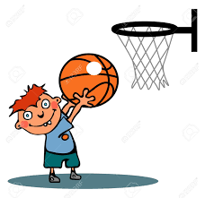

This new month is going to bring us into a new unit which is always a fan favorite, basketball! By the time this month is over, your child will be begging you to sign them up for basketball leagues
Basketball Weekly Outlook
Week 1: Dribbling
Week 2: Passing
Week 3: Shooting
Week 4: Stations and games

A few activities to look forward to
Bubble Breaker: Students needs to dribble around the gym and “pop” the spots on the floor by dribbling 3 times on them
Dribble Knockout: While walking and dribbling around the gym, students will try to knock other classmates balls out of their hands. Students will work on dribbling, control of ball and defending
Space Invaders: Students will be in teams. Some students are in hula hoops while others are around them. Those standing in hoops must successfully use any of the types of passes to get the ball to teammates in a hoop while the students on the outside must “invade” the space and prevent the pass from happening
Hot Shot: On half court of the gym, many spots are placed on floor. Each spot is worth a point depending how close or far it is from the net. When you make a shot from a spot, you pick that spot up and remember the points. Once all spots are gone, students add up the point values

